PRAS General Ledger Setup
Manual (R12)
GAIA Interfacing Programs

Client:
Shared Service Center
Finance and Accounting Department

Author:
Creation Date: January 8, 2015
Last Updated: January 8, 2015
Control Number and Version are marked by a Word Bookmark so that they can be easily reproduced in the header and footer of documents. When you change either of these values, be careful not to accidentally delete the bookmark. You can make bookmarks visible by selecting Tools->Options…View and checking the Bookmarks option in the Show region.

PROCEDURE DETAILS

Log in into Oracle Application 11i using your Username and Password

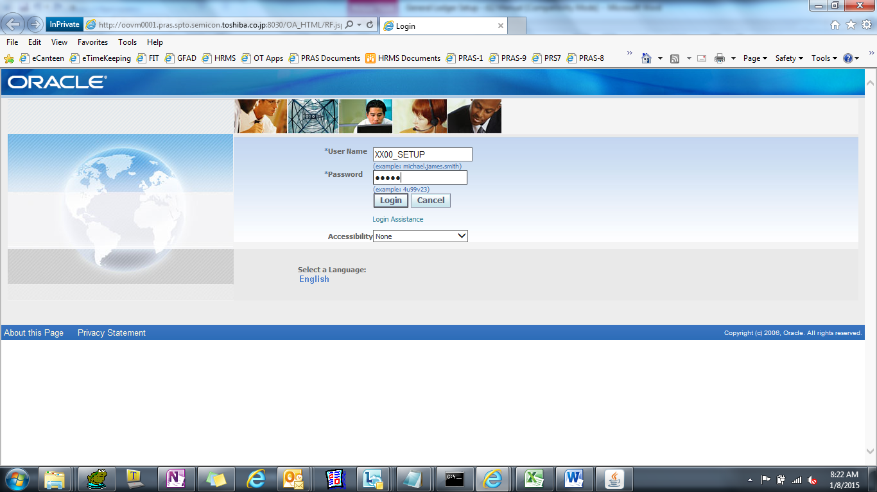

Select System Administrator Responsibility
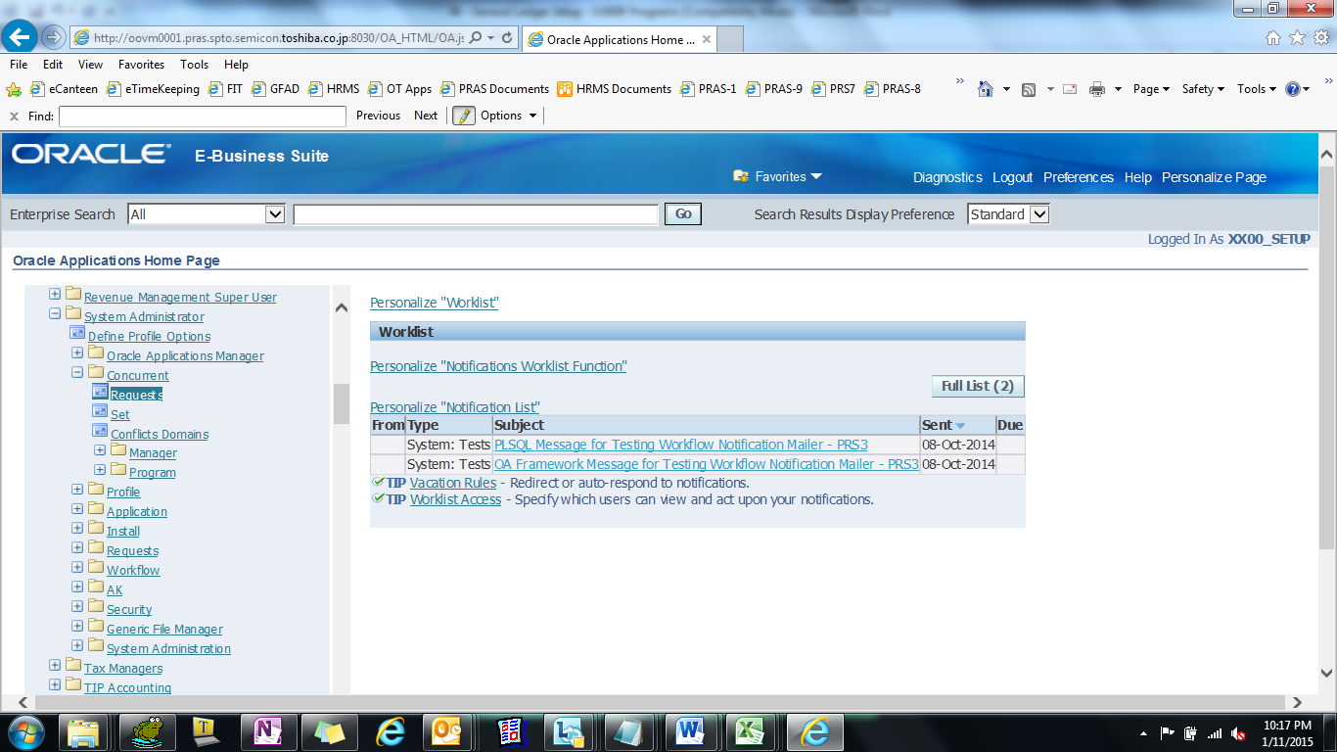

GL JOURNAL SOURCES

(N) Setup > Journal > Sources
- Find Record
- Press F11
ii. Press Ctrl+F11

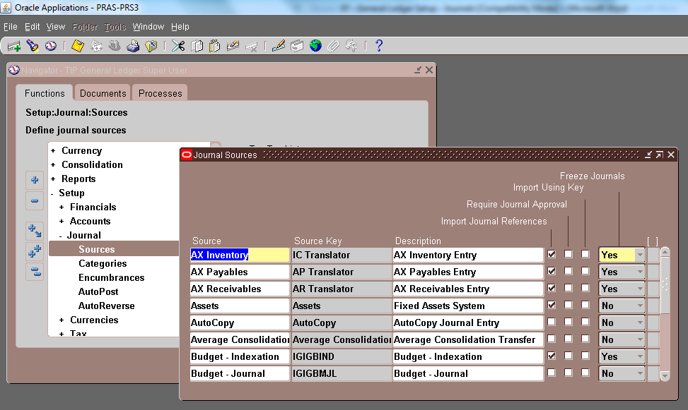

GL JOURNAL SOURCES
# | SOURCE | MEANING
1 | COST MANAGEMENT | Cost Management
2 | PAYROLL | Payroll System
3 | T090593_L10_0006 | PRS-LIQ
4 | T090593_L10_0008 | TIP Inventory Accounting

GL JOURNAL CATEGORIES

(N) Setup > Journal > Sources
- Find Record
i. Press F11
ii. Press Ctrl+F11

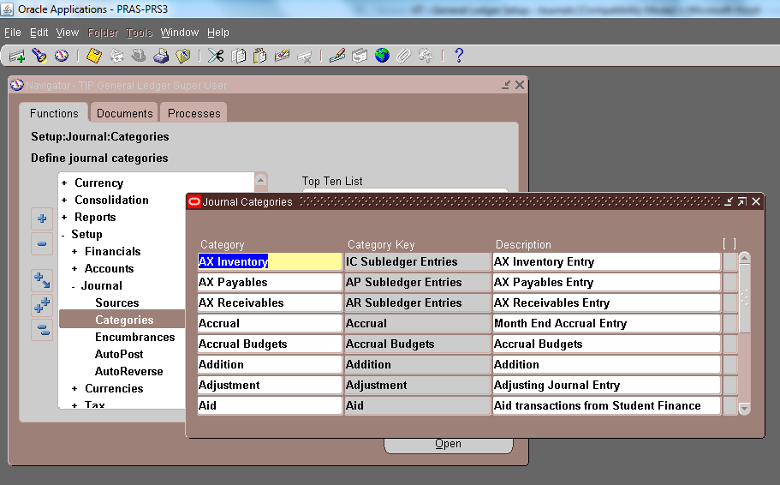

GL JOURNAL CATEGORIES
# | CATEGORY | MEANING
1 | ADDITION | Addition
2 | EHD INVENTORY | EHD Inventory
3 | EPC INVENTORY | EPC Inventory
4 | ESD INVENTORY | ESD Inventory
5 | ESP INVENTORY | ESP Inventory
6 | FRC INVENTORY | FRC Inventory
7 | HDD INVENTORY | HDD Inventory
8 | HPC INVENTORY | HPC Inventory
9 | PAYROLL | Payroll
10 | RECEIVING | Receiving
11 | SPC INVENTORY | SPC Inventory
12 | SSD INVENTORY | SSD Inventory

